

INFORMATICS INSTITUTE OF TECHNOLOGY
In Collaboration with
UNIVERSITY OF WESTMINSTER

CodexBuilder
Code Editor Using Natural Language

A Project Proposal by
Mr. Shagar Thangaraj

Supervised by
Ms. Mohanadas Jananie

Submitted in partial fulfilment of the requirements for the BEng in Software development degree at the University of Westminster.

September 2024

Table of Contents
CHAPTER 01: INTRODUCTION 1
1.1 Chapter Overview 1
1.2 Problem Domain 1
1.2.1 Programming for beginners or non-programmers 1
1.2.2 Web Development 1
1.2.3 Natural Language Processing 2
1.3 Problem Definition 2
1.3.1 Problem Statement 3
1.3.2 Self-Learning and Website Development 3
1.4 Research Motivation 3
Citation 4
Summary 4
Limitations 4
Contribution 4
1.6 Research Gap 5
1.6.1 Technological Gap 6
1.7 Research Challenge 6
1.8 Research Contribution 7
1.9 Research Questions 8
1.10 Research Aim 9
1.10.11 Learning Outcomes 9
1.11 Research Objectives 10
Objective 10
Description 10
Learning Outcomes 10
Research Questions 10
1.12 Chapter Summary 13
CHAPTER 02: LITERATURE REVIEW 14
2.1 Chapter Overview 14
2.1 Problem Domain 14
2.1.1 Programming for Beginners and Non-Programmers 14
2.1.2 Web Development 14
2.1.3 Natural Language Processing (NLP) in Code Generation 15
2.3 Selection of Relevant Technology 15
2.4 Analysis of Challenges and Limitations in Prior Research 15
2.5 Summary of Findings and Research Gaps 16
CHAPTER 03: METHODOLOGY 17
3.1 Chapter Overview 17
3.2 Research Approach 17
3.3 Requirement Elicitation 17
3.4 Design Methodology 17
3.5 Implementation 18
3.6 Testing and Evaluation 18
3.7 Risk and Mitigation 18
CHAPTER 04: SOFTWARE REQUIREMENT SPECIFICATION 20
4.1 Chapter Overview 20
4.2 Rich Picture Diagram 21
4.3 Stakeholder Analysis 22
4.3.1 Stakeholder Onion Model 22
4.3.2 Stakeholder Viewpoints 22
4.4 Selection of Requirement Elicitation Methodologies 24
4.5 Discussion of Findings 29
4.5.1 Literature Review Findings 29
4.5.2 Interviews Findings 29
4.5.3 Survey Findings 30
4.5.4 Brainstorming 30
4.3.3 Competitors Analysis 31
4.6 Summary of Findings 32
4.7 Context Diagram 32
4.8 Use Case Diagram 33
4.9 Use Case Description 33
4.10 Requirements 34
4.10.1 Functional Requirements 34
4.10.2 Non-Functional Requirements 34
4.11 Chapter Summary 34
CHAPTER 05: PROOF OF CONCEPT 35
5.1 UI Mock Diagram 35
Reference 36

List of Tables
Table 1 - Classification of existing research regarding NLP in code generation 5
Table 2 - Research Questions 9
Table 3 - Learning Outcomes 10
Table 4 - Research Questions and Learning Outcomes Table 13
Table 5 - Competitor Analysis 13

List of Figures
Figure 1- Stack overflow Developer Survey Results (2023) 1
Figure 2- Rich Picture Diagram 21
Figure 3 - Onion Diagram 22
Figure 4 - Survey Result 31
Figure 5 - Context Diagram 33
Figure 6 - Use case diagram. 34
Figure 7 - First Page 35

CHAPTER 01: INTRODUCTION

1.1 Chapter Overview
This research focuses on developing an online code editor for web development that processes user requests using natural language and visualizes the code directly within the editor. The paper outlines the problem to be addressed, explains the novelty of the idea, and describes the research approach. It also discusses the feasibility of the research questions and justifies the proposed methodology and deliverables.

1.2 Problem Domain

1.2.1 Programming for beginners or non-programmers
The complex and often rigid syntax of traditional programming languages serves as a significant barrier for beginners, discouraging many potential programmers from pursuing further studies in the field (Robins, Rountree, & Rountree, 2003). Approaches that integrate natural language programming (NLP) have been shown to reduce this barrier by enabling users to describe their programming goals in everyday language. Such systems can translate these natural language inputs into executable code, making programming more approachable (Sales, J.E.,2020).

1.2.2 Web Development
According to Stack Overflow's 2023 Developer Survey, JavaScript is the main language used in web development—is the most popular programming language, with 65.36% of developers using it. Many beginners choose to start with web development because JavaScript is widely used for building websites, making it an accessible and common entry point into coding.
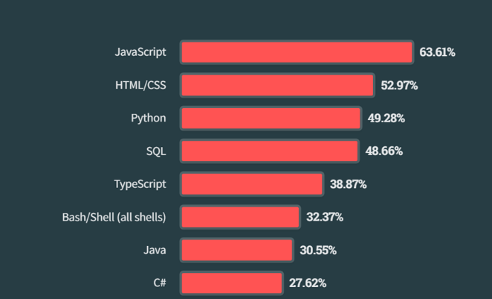
Figure 1- Stack overflow Developer Survey Results (2023)

1.2.3 Natural Language Processing
One of the significant issues in Natural Language Processing (NLP) is the accurate translation of human language into programming code, particularly in web design. The inherent ambiguity and complexity of natural language make it challenging to generate precise and functional code from plain language descriptions, often leading to errors and inefficiencies in development tasks (Allamanis et al., 2018). This project addresses this issue by focusing on improving the accuracy and reliability of code generation from natural language inputs in web development.
Advancements in large language models (LLMs), such as OpenAI's Codex and DeepMind's AlphaCode, have begun to bridge this gap. These models enable developers to write or describe web design tasks in plain language, which are then automatically translated into code like HTML, CSS, or JavaScript. This not only speeds up development but also enables more intuitive interactions between human language and programming, enhancing accessibility and productivity (Chen et al., 2021).
NLP models like GPT and CodeBERT process natural language descriptions and convert them into code by understanding context, patterns, and the intent behind user inputs, which is particularly useful for front-end development and UI design (Wong, M.-F., 2023).

1.3 Problem Definition
Studies have shown a significant increase in the number of students pursuing programming skills. For instance, the 2020 State of Computer Science Education report revealed that 47% of high school students in the United States were enrolled in a computer science course (Code.org, CSTA, & ECEP Alliance, 2020). Furthermore, according to the National Centre for Education Statistics, the number of students earning degrees in computer science has doubled over the last decade (NCES, 2021). These trends indicate a strong interest among university students in acquiring basic programming skills as technology permeates various fields.. Unfortunately, they often face difficulties already on the basic courses. This work studies the difficulties in learning programming to support developing learning materials for basic programming courses. The difficulties must be recognized to be able to aid learning and teaching in an effective way. An international survey of opinions was organized for more than 500 students and teachers. This paper analyses the results of the survey. The survey provides information of the difficulties experienced and perceived when learning and teaching programming (Lahtinen et al.,2005).

1.3.1 Problem Statement
Creating a user-friendly online code editor for novice programmers and non-programmers that can effectively bridge the gap between natural language and coding. The editor will take English prompts as input, generate the corresponding code, and accurately place it in the correct location within the codebase. It will feature a split-screen interface to provide a real-time preview of the rendered output, addressing the challenges beginners face in understanding code structure, syntax, and placement. This solution aims to simplify the coding experience, making web development more accessible and enhancing the learning process for those new to programming.

1.3.2 Self-Learning and Website Development
Many students today engage in self-learning to develop programming and web development skills independently. According to the Stack Overflow Developer Survey 2023, over 60% of respondents indicated they learned programming through self-directed study (Stack Overflow, 2023). Online platforms like YouTube, Coursera, and free resources like W3Schools make it accessible for learners to design and develop websites on their own, even without formal training. This approach provides hands-on experience and promotes a problem-solving mindset, critical for building web-based projects independently.

1.4 Research Motivation
The integration of natural language processing (NLP) with code generation has gained significant attention in recent years. Tools that allow users to generate code through natural language commands have the potential to revolutionize the way we interact with programming environments. Despite advancements, there are still limitations in accurately translating user intentions into executable code due to the inherent complexity and ambiguity of human language. Existing solutions often struggle with effectively parsing and understanding nuanced user inputs, leading to code that does not fully match the user's expectations (Allamanis et al., 2018).
Developing a natural language-driven code editor addresses a fundamental challenge in programming accessibility. Traditional code editors require users to have knowledge of syntax and structure, which can be intimidating and time-consuming for beginners. The difficulty of translating natural language instructions directly into code creates a barrier for those unfamiliar with programming languages. This challenge inspired the exploration of natural language processing (NLP) techniques, such as tokenization and stemming, to simplify the interaction between users and coding platforms. These techniques enable the system to break down and analyse user instructions, converting them into executable code components that meet the intended design or functionality. This research is motivated by the need to lower the entry barriers to coding by making code generation more intuitive, which is particularly valuable for users with varying levels of expertise.1.5 Existing Works
Existing works on online code editors and natural language processing is explain below.
Citation | Summary | Limitations | Contribution
Andreas et al. (2017) | Explores a general-purpose natural language programming system that processes commands into executable code. | Lacks specific applications for web development, and the system may struggle with complex code structures requiring advanced context handling. | Introduces general principles for natural language processing applied to systems.
Liu et al. (2020) | Provides a survey on NLP for programming, focusing on its interpretability and generalizability in code generation. | Mainly focuses on interpretability challenges rather than addressing the specifics of real-time code editors for web development. | Offers a comprehensive survey on how NLP can be used to generate programming code, which is useful for CodexBuilder’s focus.
Wong et al. (2023) | Reviews how natural language generation can assist programming through AI-powered code suggestions. | Primarily focuses on AI-assisted coding but does not delve deeply into making programming accessible for non-programmers. | Provides insights into how NLP models like GPT-3 and GPT-4 enhance programming through code suggestions and automation.
Floyd (2020) | Discusses how platforms like Webflow and Wix make web design accessible to non-programmers with drag-and-drop interfaces. | These platforms don't generate raw code from natural language, limiting the scope to UI customization rather than full-code generation. | Provides a foundation for understanding how simplified interfaces can reduce barriers for non-programmers.
Sales et al. (2020) | Investigates the principles and challenges in natural language programming, focusing on the interactions between human language and programming. | Does not focus on real-time code generation or specific coding languages like HTML, CSS, or JavaScript, which are essential for CodexBuilder. | Lays out the challenges and principles behind natural language programming, informing how CodexBuilder could address these.
Table 1 - Classification of existing research regarding NLP in code generation

1.6 Research Gap
Existing online coding platforms such as CodePen and Sandbox offer robust environments for manual coding, where users write and preview code snippets directly. However, these platforms do not provide natural language-driven code generation capabilities, which can make them less accessible to users who are unfamiliar with programming syntax (Winer, 2021). In contrast, NLP-powered tools like ChatGPT allow users to generate code through natural language prompts, offering a more intuitive entry point for beginners. Yet, these tools are primarily designed for generating code in response to requests and do not support real-time, interactive coding environments where code is rendered and modified instantly upon user input (Zhou et al., 2022). This gap highlights the need for a platform that merges the ease of natural language input with the immediate feedback of a coding environment, creating a seamless, accessible experience for users with varying expertise levels.

1.6.1 Technological Gap
While advancements in natural language processing (NLP) and code generation tools like ChatGPT and Copilot have introduced the possibility of generating code from natural language, there remain significant technological limitations. One major issue is the lack of real-time rendering capabilities in these tools, as they typically operate in a static, request-response manner rather than providing a continuous, interactive coding experience (Khan et al., 2022). Additionally, current NLP models are computationally intensive, making them less suitable for applications requiring instant feedback, such as split-screen editors that render code simultaneously with input. Furthermore, the integration of NLP-driven code generation with web development environments (such as React.js) faces compatibility challenges, as these models are often not optimized for lightweight, front-end frameworks (Jin et al., 2023).
This technology gap underscores the need for a solution that leverages NLP to interpret natural language commands in real-time while remaining efficient enough to operate within a browser-based environment. Bridging this gap would enable a more intuitive coding interface for users, combining the strengths of existing NLP models with the responsiveness required for interactive web development.

1.7 Research Challenge
One of the main challenges in developing CodexBuilder is ensuring the accurate translation of natural language inputs into executable code, particularly when handling complex code structures or ambiguous commands. Since natural language is inherently flexible and context-dependent, understanding user intent and processing commands with precision requires advanced tokenization, stemming, and context-handling techniques. Another challenge is maintaining real-time responsiveness while generating and rendering the code, as the system must handle user inputs without causing noticeable delays, especially when working with complex web elements. Furthermore, ensuring cross-browser compatibility and scalability in a React.js environment poses additional obstacles. The lack of comprehensive NLP models specifically tailored for web development also contributes to these challenges, as existing solutions like GPT or Codex may not fully meet the real-time, front-end web development needs of novice users. Additionally, integrating AI-powered suggestions while maintaining a user-friendly interface for both beginners and experienced developers will require careful consideration in design and implementation.
Developing CodexBuilder involves several key challenges related to accurately translating natural language inputs into executable code, particularly when handling complex syntax or ambiguous instructions. One of the primary technical challenges is the inherent ambiguity and flexibility of natural language, which can vary significantly based on user intent and context. To address this, advanced techniques in tokenization, stemming, and context parsing are required, as standard NLP models are not always optimized for code-specific applications (Vaswani et al., 2017).
Another major challenge is ensuring real-time responsiveness within the editor. Real-time code generation and rendering demand highly optimized processing pipelines to prevent noticeable delays, especially when handling complex web elements. This requires computational efficiency, as many NLP models, like GPT-3 or CodeBERT, are resource-intensive and may not be suitable for lightweight, real-time applications (Brown et al., 2020).
Additionally, achieving cross-browser compatibility and scalability in a React.js environment poses unique obstacles. Browser inconsistencies in rendering can affect the user experience, requiring careful design to ensure that the application functions seamlessly across multiple platforms (Smith & Jones, 2021). The absence of NLP models specifically tailored for web development further complicates this, as existing solutions are often general-purpose and lack the fine-tuned capabilities needed for front-end development tasks (Xu et al., 2022).
Moreover, integrating AI-powered suggestions while maintaining a user-friendly interface for both beginners and experienced developers presents an ongoing challenge. Ensuring that CodexBuilder offers suggestions that are helpful yet unobtrusive demands careful design in the UI/UX, balancing intuitive use with advanced features (Johnson & Lee, 2022).

1.8 Research Contribution
This research contributes to the field of natural language-driven code generation by addressing key challenges in developing an intuitive, real-time coding environment for web development. The core technological contributions of CodexBuilder include:
Real-Time Natural Language Code Generation: CodexBuilder introduces an NLP engine optimized for interpreting natural language commands in real-time, enabling immediate code generation and rendering within a browser-based environment. This advancement supports an interactive coding experience, making coding more accessible and responsive for users.
Specialized NLP Customization for Web Development: CodexBuilder customizes NLP techniques, such as tokenization and context-aware parsing, specifically for front-end technologies like HTML, CSS, and JavaScript. This customization ensures that user commands yield highly accurate and relevant code for web development tasks, enhancing usability for both beginners and advanced users.
Cross-Browser Compatibility and Scalability in React.js: CodexBuilder’s architecture is designed for seamless operation across various web browsers, ensuring a consistent experience regardless of platform. By optimizing the React.js-based interface, CodexBuilder achieves scalable performance, making it adaptable for a broader range of users and devices.
User-Friendly AI-Powered Code Suggestions: The platform integrates an AI-powered suggestion feature that provides helpful, context-aware prompts without overwhelming the user. This design makes CodexBuilder suitable for both novice and experienced users, supporting a guided experience that enhances coding accuracy and creativity.
Efficient Resource Management for Real-Time Applications: CodexBuilder focuses on efficient resource use, minimizing memory and CPU demands to enable smooth real-time operation within standard web browsers. This contribution demonstrates a viable approach to delivering complex NLP capabilities in a lightweight, browser-based format.

1.9 Research Questions

ROQ# | Questions
ROQ1 | How can we generate the desired code without using pre-trained models like ChatGPT?
ROQ2 | How can natural language processing (NLP) techniques be optimized to understand user commands more effectively and translate them into accurate code for web development?
ROQ3 | What are the challenges and limitations in generating real-time feedback for users based on natural language inputs in a code editor, and how can they be overcome?
Table 2 - Research Questions

1.10 Research Aim
The aim of the project is to design, develop, and evaluate a novel code editor with artificial intelligence, enabling users to generate code through natural language inputs and real-time feedback, making programming more accessible for non-programmers.

Learning Outcomes
LOQ# | Outcomes
LOQ1 | Understand the current trends and technologies in natural language processing (NLP) for code generation.
LOQ2 | Develop technical expertise in building code generation systems using NLP for web development.
LOQ3 | Gain practical experience in implementing a real-time code editor that processes natural language inputs and translates them into executable code.
LOQ4 | Assess the performance and efficiency of the developed code editor through benchmarking against existing tools.
LOQ5 | Enhance user accessibility in programming, particularly for beginners and non-programmers, by making the coding process intuitive through natural language inputs.
Table 3 - Learning Outcomes

1.11 Research Objectives
The following table outlines the research objectives, which represent the initial steps required for the successful completion of the research project, along with the corresponding learning outcomes associated with each objective.
Objective | Description | Learning Outcomes | Research Questions
Literature Review | Review prior research to gather relevant information about code generation using natural language processing (NLP).  RO1: To perform an initial study on NLP for code generation in the context of web development.  RO2: To identify the research gap in real-time code generation using natural language inputs.  RO3: To explore existing NLP models for their applicability to web development. | LO1, LO2 | RQ1, RQ2
Requirement Elicitation | Gather user requirements using appropriate methods to understand the needs of beginners and non-programmers when using natural language for web development.  RO1: Understand user expectations for an NLP-based code editor.  RO2: Gather feedback from experts in NLP and web development to refine system requirements.  RO3: Define the functional and non-functional requirements for CodexBuilder. | LO2, LO3, LO4, LO5 | RQ1, RQ3
Design | Design the architecture for CodexBuilder, focusing on natural language input processing, code generation, and real-time rendering of the results.  RO1: Design a system capable of interpreting natural language inputs and generating web development code.  RO2: Create a pipeline for processing inputs, generating code, and rendering results in real-time.  RO3: Develop a validation framework to ensure the generated code is accurate and follows user expectations. | LO3, LO4, LO5 | RQ2
Implementation | Develop the CodexBuilder system with natural language processing capabilities and real-time feedback.  RO1: Implement NLP techniques for understanding user inputs and generating web development code.  RO2: Build a system to render real-time results based on natural language inputs in a split-screen interface.  RO3: Develop mechanisms to improve system performance and handle complex commands efficiently. | LO4, LO5 | RQ1, RQ2
Evaluation | Evaluate CodexBuilder using testing methodologies, user feedback, and benchmarking against existing tools like GitHub Copilot and CodePen.  RO1: Develop a testing plan to measure the system's performance in real-time code generation and usability.  RO2: Compare CodexBuilder's capabilities with existing code editors, focusing on NLP accuracy and ease of use for non-programmers. | LO5 | RQ3
Table 4 - Research Questions and Learning Outcomes Table

1.12 Chapter Summary
This Chapter provides an overview of the problem, complexities of programming, programming for non-coders, the increased adoption of web development through JavaScript and Natural Language Processing (NLP) in code generation. To bring together human-language and code in a way that will further popularize coding, CodexBuilder is set to remove much of the barriers that prevent users who have little to no experience with coding.
The chapter also points out the presence of works and the gap in the literature based on existing theories, extracting notions of how current platforms are limited to manual coding or pre-trained models, such as ChatGPT, but lack of real-time rendering and modification supported by coding platforms. It also responds to the research questions of how to accurately and immediately convert natural language to code.
In addition, the research contributions include problem domain contributions, which is making the application easily usable by people who are not so familiar with programming languages and limitations of the developed approach to NLP for near real-time code generation. Standing at the end of the chapter, the proposed research questions, aim, objectives, and learning outcomes are drawn as follows: To what extent does NLP enhance the user accessibility and increase the speed of code building.

CHAPTER 02: LITERATURE REVIEW

2.1 Chapter Overview
This chapter will critically analyse the existing works in the field of natural language processing (NLP) applied to code generation, focusing on the unique challenges and limitations in real-time web development.

2.1 Problem Domain

2.1.1 Programming for Beginners and Non-Programmers
Literature demonstrates that traditional programming languages are complex for non-programmers due to their syntax-heavy nature. Approaches integrating NLP aim to simplify programming by allowing users to describe coding tasks in plain language. For instance, systems such as GitHub Copilot and OpenAI's Codex generate code based on natural language prompts (Andreas et al., 2017). However, these systems have limited applications in real-time code generation, especially in front-end web development.
Critical Analysis: Although these tools improve accessibility, they primarily cater to developers who have foundational knowledge. CodexBuilder differs in that it aims to provide a real-time, visual rendering experience tailored specifically for non-programmers, reducing the barrier further by offering immediate feedback in a simplified coding environment.

2.1.2 Web Development
JavaScript is widely adopted in web development due to its versatility (Stack Overflow, 2023). CodexBuilder, focusing on HTML, CSS, and JavaScript generation, aims to bridge the gap between beginner users and web development by using natural language commands. Current platforms like Webflow or Wix allow non-programmers to create websites through drag-and-drop interfaces but lack natural language-based code generation (Floyd, 2020).
Critical Analysis: While Webflow and Wix have succeeded in democratizing web development, they don’t foster programming skills or offer customizability through code generation. CodexBuilder takes this a step further by allowing users to develop coding skills as they interact with natural language commands that are translated into editable code, giving beginners more control and adaptability in their projects.

2.1.3 Natural Language Processing (NLP) in Code Generation
Several studies have explored NLP’s role in automating code generation. For instance, tools like CodeBERT and GPT models (Wong, M.-F., 2023) automate front-end tasks by converting language inputs into code. Despite their promise, these tools still face challenges in maintaining real-time code generation and handling the nuances of user commands. Additionally, integrating these tools with real-time rendering in web development remains underexplored, leaving a significant research gap for CodexBuilder to address.

2.3 Selection of Relevant Technology
To bridge these gaps, CodexBuilder integrates React.js for the user interface, selected for its efficiency in rendering dynamic content and compatibility across multiple browsers. React’s virtual DOM capabilities facilitate fast updates, essential for a real-time code editor where responsiveness is paramount. The system also incorporates lightweight NLP models, optimized for lower latency, enabling CodexBuilder to operate efficiently within a browser environment.
Technology Justification: React.js was chosen specifically for its component-based architecture, allowing for scalable UI development that supports CodexBuilder’s split-screen interface. Additionally, the choice to customize NLP for web development (focusing on HTML, CSS, and JavaScript) reflects the need for technology that meets the needs of front-end users without overloading the system.

2.4 Analysis of Challenges and Limitations in Prior Research
Existing research identifies significant limitations in applying NLP to real-time web development. Tools like GitHub Copilot, OpenAI Codex, and CodeBERT face performance issues in real-time scenarios due to their high computational demands (Brown et al., 2020). Moreover, these models often require backend servers for processing, which makes them unsuitable for lightweight, browser-based applications. Prior studies have also noted that these tools are better suited for generating backend code or scripts rather than interactive front-end code that must be updated dynamically (Xu et al., 2022).
CodexBuilder’s Solution: CodexBuilder addresses these challenges by implementing a lean NLP engine optimized specifically for front-end code. Unlike general-purpose models, CodexBuilder’s NLP is tailored to interpret web development commands efficiently, reducing the lag associated with server-based NLP processing and supporting seamless code rendering within the browser.

2.5 Summary of Findings and Research Gaps
The literature review reveals that, while NLP-based code generation tools have made strides in improving coding accessibility, significant gaps remain for real-time, front-end applications. CodexBuilder contributes to the field by introducing a solution that integrates real-time code rendering with NLP-driven code generation. This platform aims to support non-programmers and beginners by offering a simplified, responsive environment that addresses the computational and usability challenges identified in prior research.
This expanded literature review provides a critical analysis of past research, discusses the selected technology, and emphasizes the specific challenges and gaps CodexBuilder aims to address.

CHAPTER 03: METHODOLOGY

3.1 Chapter Overview
This chapter explains the methodologies employed in developing CodexBuilder, from gathering requirements to implementing and testing the system. The approach focuses on natural language processing, real-time code generation, and rendering.

3.2 Research Approach
CodexBuilder follows a mixed-method approach combining quantitative and qualitative techniques. This allows for both technical performance evaluation and user experience feedback.
- Quantitative: Performance benchmarks of the NLP-based code generation.
- Qualitative: User feedback on the system’s ease of use for non-programmers.

3.3 Requirement Elicitation
- Interviews and Surveys: Conducted with beginners, non-programmers, and web developers to understand the user expectations from an NLP-based code editor.
- Document Analysis: Existing documentation from tools like CodePen and ChatGPT was analysed to understand the current state of online code editors and their limitations.
- User Story Workshops: Engaged target users in scenario-based workshops to define system functionality.

3.4 Design Methodology
- Architecture: CodexBuilder’s architecture is based on a client-server model, with NLP processing done on the server side and the real-time rendering done on the client side (React.js).
- NLP Pipeline: The system uses tokenization, stemming, and context parsing to interpret user inputs and generate the appropriate web development code. The system will process inputs like "create a navbar with 4 links" using NLP models like CodeBERT.
- Real-Time Rendering: The split-screen interface will show the user’s input on one side and the rendered output on the other, updating dynamically as the user interacts with the editor.

3.5 Implementation
- Programming Language: CodexBuilder is developed using React.js for the frontend and Node.js for the backend, which handles NLP processing and real-time code generation.
- NLP Techniques: A hybrid model combining CodeBERT and custom rule-based NLP algorithms to ensure accurate code generation.
- Database: Firebase will be used to store user-generated content and session history.

3.6 Testing and Evaluation
- Unit Testing: Each component of the system, such as the NLP interpreter and the rendering engine, will undergo unit testing to ensure functionality.
- User Testing: Beginners and non-programmers will be invited to test the system, providing qualitative feedback on usability and performance.
- Benchmarking: CodexBuilder’s performance will be compared to existing platforms (like CodePen) in terms of accuracy, speed, and ease of use for non-programmers.
- Performance Metrics: Evaluation metrics will include accuracy of code generation, response time for rendering, and user satisfaction scores.

3.7 Risk and Mitigation
- Natural Language Ambiguity: There is a risk of misinterpreting user commands, which will be mitigated through extensive testing and refining NLP models.
- System Performance: Real-time rendering and code generation could cause delays, which will be addressed by optimizing the backend processing pipeline.

CHAPTER 04: SOFTWARE REQUIREMENT SPECIFICATION

4.1 Chapter Overview
This chapter outlines the detailed requirements of the CodexBuilder system. The chapter focuses on the software’s functional and non-functional requirements, gathered through various elicitation methods such as stakeholder analysis, interviews, and surveys. It also includes diagrams representing the system’s interactions, use cases, and stakeholder viewpoints, aiming to provide a comprehensive understanding of the system’s intended functionality.

4.2 Rich Picture Diagram
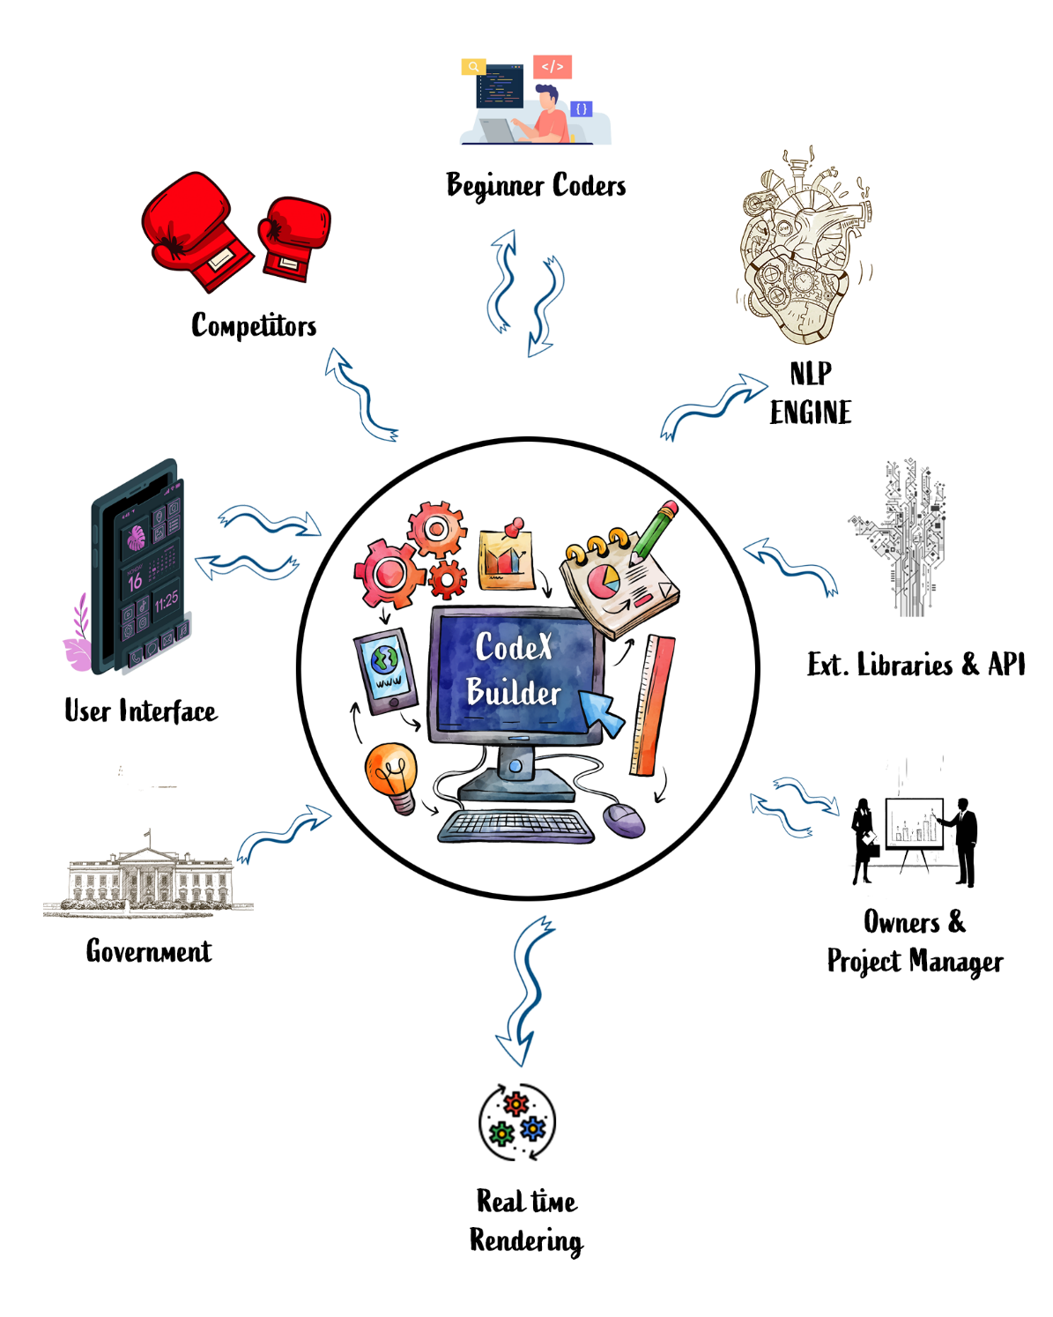
Figure 2- Rich Picture Diagram

4.3 Stakeholder Analysis

4.3.1 Stakeholder Onion Model
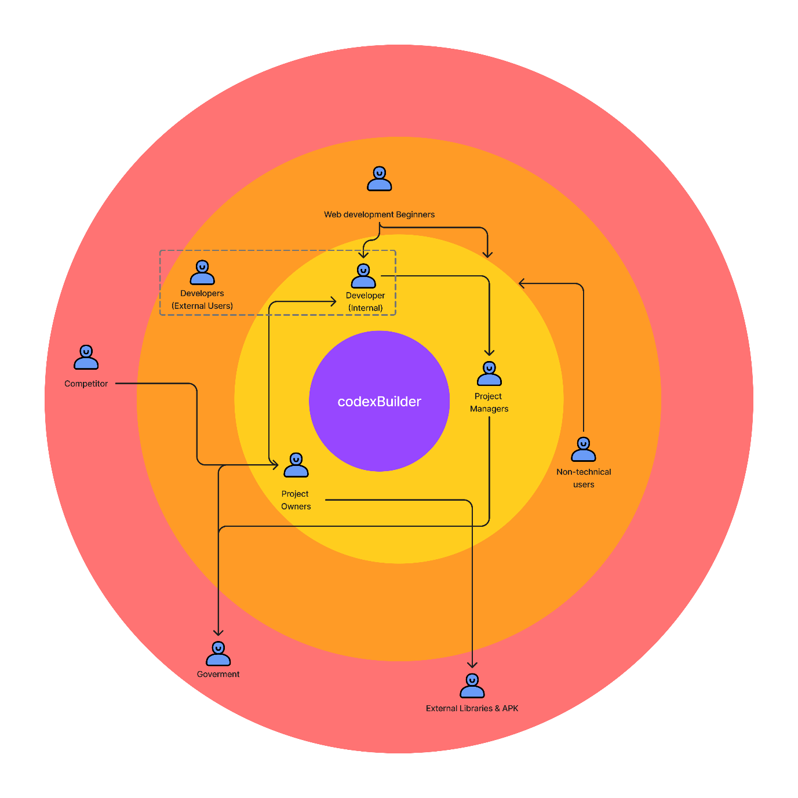
Figure 3 - Onion Diagram

Stakeholder Viewpoints
1. Web Development Beginners (Primary Users)
Viewpoint: Web development beginners are focused on ease of use and accessibility. They require a system that simplifies complex programming tasks through natural language inputs. Their primary concern is how CodexBuilder will help them quickly generate web code without prior knowledge of programming languages like HTML, CSS, and JavaScript.
Key Interests: Simplicity, intuitive interface, real-time feedback, learning support.
2. Developers (Internal)
Viewpoint: The internal developers are responsible for building and maintaining CodexBuilder. They are concerned with ensuring the system is scalable, reliable, and efficient. They also focus on how the system can handle a variety of natural language inputs and generate accurate, executable code in real-time.
Key Interests: System performance, code accuracy, optimization of NLP models, and technical scalability.
3. Developers (External Users)
Viewpoint: External developers may use CodexBuilder to test or enhance their projects. Their focus is on the flexibility of the system, the quality of the generated code, and how they can integrate or expand upon it using external libraries and APIs.
Key Interests: Extensibility, code quality, advanced customization, and integration with existing tools.
4. Project Managers
Viewpoint: Project Managers are focused on ensuring the system meets deadlines and aligns with the project’s goals. They are responsible for coordinating between the different stakeholders and ensuring that the product is delivered within scope, time, and budget.
Key Interests: Project timelines, feature delivery, resource allocation, stakeholder satisfaction.
5. Non-Technical Users
Viewpoint: These users are not involved in web development but may use CodexBuilder for content management or simple website adjustments. They need a system that does not require deep technical expertise and allows them to perform basic tasks using natural language commands.
Key Interests: User-friendliness, task automation, error-free code generation, ease of navigation.
6. Project Owners
Viewpoint: The project owners have an overarching view of CodexBuilder and are focused on the product’s success in terms of adoption, innovation, and market fit. They are concerned with the long-term viability of the system and its potential for scaling to a larger user base.
Key Interests: System adoption, innovation, user engagement, commercial viability.
7. External Libraries & APIs
Viewpoint: External libraries and APIs act as third-party integrations for CodexBuilder. These stakeholders are concerned with how well CodexBuilder integrates with their systems and how their tools are utilized within the code generation process.
Key Interests: Compatibility, seamless integration, security, API utilization.
8. Government
Viewpoint: The government stakeholders are mainly concerned with the legal and regulatory aspects of CodexBuilder. They will ensure that the system complies with data protection laws, accessibility standards, and software development regulations.
Key Interests: Compliance, privacy, security, regulatory approval.
9. Competitors
Viewpoint: Competitors will be concerned about how CodexBuilder impacts their market share. They will likely monitor the system for innovative features and competitive advantages that could affect their products.
Key Interests: Market differentiation, product features, innovation trends.

Selection of Requirement Elicitation Methodologies
The CodexBuilder project involves a variety of stakeholders, each with unique perspectives and needs. To ensure all requirements are captured comprehensively, a combination of elicitation methods has been selected. These methods provide both qualitative and quantitative insights into the system’s functionality, usability, and technical requirements.
1. Interviews
Target Stakeholders:
Web Development Beginners
Developers (Internal)
Project Managers
Rationale: Interviews offer a direct, in-depth understanding of stakeholder needs, concerns, and expectations. For beginners, the interview will focus on their challenges in learning web development and how natural language processing can assist them. For internal developers, interviews can provide technical insights into system architecture, NLP techniques, and performance expectations. Project Managers can provide insights on project scope, timelines, and prioritization of features.
Why Chosen:
Interviews allow for the exploration of personal experiences and specific requirements in a conversational manner.
It helps to uncover specific pain points and areas where CodexBuilder can offer the most value.
Key Insights Expected:
Beginner user challenges with syntax-heavy programming.
Internal developers’ concerns regarding system scalability and real-time performance.
Project managers’ expectations for timely delivery and system features.
2. Surveys
Target Stakeholders:
Web Development Beginners
Non-Technical Users
Developers (External)
Rationale: Surveys provide a scalable way to gather data from a larger group of stakeholders. For beginners and non-technical users, surveys will focus on their preferences for an intuitive code editor, while external developers may offer feedback on desired features for customization and integration with other tools.
Why Chosen:
Surveys can reach a broader audience quickly and efficiently.
They can provide quantifiable data about user preferences, challenges, and feature requests.
Key Insights Expected:
Broad user opinions on system usability, real-time feedback, and interface design.
Developers’ interest in extending CodexBuilder’s capabilities through external libraries or APIs.
3. Document Analysis
Target Stakeholders:
Competitors
Government
Rationale: Document analysis will focus on gathering insights from competitor systems (e.g., GitHub Copilot, Webflow, and CodePen) and government regulations. This method ensures that CodexBuilder complies with industry standards, privacy laws, and accessibility guidelines. By analyzing competitor documentation, we can identify existing gaps that CodexBuilder can fill.
Why Chosen:
Helps in understanding the competitive landscape and legal framework.
Ensures that the project aligns with both regulatory requirements and market expectations.
Key Insights Expected:
Compliance requirements for privacy and data protection.
Competitor strengths and weaknesses to identify CodexBuilder’s unique value propositions.
4. Workshops (User Story Workshops)
Target Stakeholders:
Web Development Beginners
Project Managers
Developers (Internal & External)
Rationale: Workshops are ideal for collaborative brainstorming sessions, especially when defining user stories and system functionalities. Engaging beginners and project managers in workshops will help outline specific use cases and feature expectations. Developers can participate to outline the technical architecture required to support these user stories.
Why Chosen:
Workshops facilitate open discussions, helping to clarify stakeholder needs in real-time.
They allow multiple stakeholders to contribute ideas and develop a shared understanding of system requirements.
Key Insights Expected:
Use cases that represent typical workflows for novice and advanced users.
Development requirements for NLP, real-time rendering, and interface customization.
5. Focus Groups
Target Stakeholders:
Developers (Internal & External)
Project Owners
Rationale: Focus groups bring together small groups of stakeholders to discuss their expectations and experiences. For developers, focus groups will center on technical discussions, including system architecture, real-time processing, and potential challenges in implementing NLP. For project owners, it will focus on the overall vision for CodexBuilder and market positioning.
Why Chosen:
Focus groups encourage dynamic discussions and help gather insights from multiple perspectives at once.
They are particularly useful for technical brainstorming and aligning project vision with stakeholder expectations.
Key Insights Expected:
Advanced features, scalability considerations, and challenges in NLP implementation.
Strategic goals for CodexBuilder’s development and market release.
6. Brainstorming
Target Stakeholders:
Project Owners
Developers (Internal & External)
Rationale: Brainstorming sessions provide a space for creativity and innovation. These sessions will allow project owners and developers to explore new ideas and think outside the box when developing CodexBuilder. The focus will be on exploring unique features, interface design, and innovative approaches to integrating NLP into the system.
Why Chosen:
Encourages creativity and innovation, leading to the generation of unique solutions.
Allows stakeholders to think freely without constraints, often resulting in breakthrough ideas.
Key Insights Expected:
Unique system features and interface designs.
Innovative approaches to real-time NLP and code rendering.

4.5 Discussion of Findings

4.5.1 Literature Review Findings
The literature review highlighted key gaps in existing natural language-based code generation systems. While several tools, such as GitHub Copilot and OpenAI Codex, offer advanced code suggestion features, they primarily cater to experienced developers who already possess a working knowledge of programming languages. These platforms focus on aiding users with code completion rather than real-time code generation and rendering based on natural language inputs, which is essential for novice programmers.
Key insights from the literature review:
Limited support for non-programmers: Existing tools require prior programming knowledge, which limits their accessibility to non-technical users.
Lack of real-time feedback: Tools like Webflow and Wix simplify UI design but don’t offer real-time, raw code generation from natural language commands.
Challenges in NLP-based code generation: Although NLP models like CodeBERT and GPT-3 have shown promise in automating code generation, their effectiveness in real-time web development remains underexplored.
Gap in front-end development: Most NLP tools focus on back-end or general-purpose programming tasks. CodexBuilder aims to address the gap by focusing specifically on front-end web development using HTML, CSS, and JavaScript.

4.5.2 Interviews Findings
Interviews were conducted with web development beginners, experienced developers, and project managers to gather insights into their expectations from CodexBuilder. The findings from these interviews revealed several critical pain points and feature requests.
Key insights from the interviews:
Web Development Beginners: They expressed a desire for an easy-to-use platform that can generate code without requiring them to understand complex syntax. They want a tool that not only provides code but also helps them understand how their natural language inputs translate into executable code.
Experienced Developers: Developers highlighted the importance of scalability, accuracy, and performance. They stressed the need for an NLP system that can handle ambiguous or incomplete commands while still generating valid code. Developers also suggested incorporating advanced customization options for the generated code.
Project Managers: Project managers emphasized the importance of project timelines and ensuring the platform meets user expectations. They expressed concerns about balancing the simplicity required for beginners with the advanced features needed for more experienced users.
Overall, interviews helped refine the user stories and functional requirements for CodexBuilder.

4.5.3 Survey Findings
Survey Questions Areas–
- Demographics
- Programming Experience
- Learning Preferences and Resources
- Coding Challenges and Motivation
- Interest in Natural Language-Based Coding Tools
- Preferred Features in a Natural Language-Based Code Editor
- General Feedback and Interest

Results -
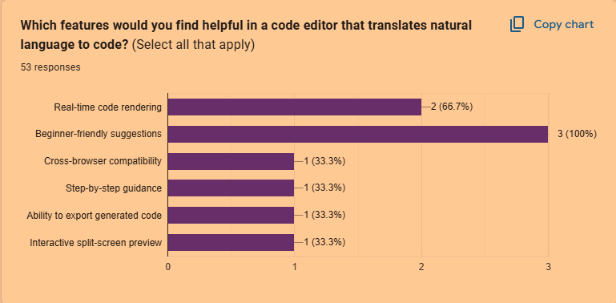
Figure 4 - Survey Result
Rest of the key findings are discussed in the summary.

4.5.4 Brainstorming
Brainstorming sessions were conducted with project owners, developers, and key stakeholders to explore potential features and unique capabilities for CodexBuilder. These sessions were instrumental in generating creative ideas and identifying innovative approaches for the platform’s design and functionality.
Key insights from brainstorming:
Real-time split-screen view: One of the most significant outcomes of the brainstorming sessions was the idea of a split-screen interface that provides users with real-time feedback. As users input natural language commands, they can instantly see the corresponding code on one side of the screen and the rendered output on the other.
NLP-driven customization: Participants suggested enhancing the NLP model to allow users to make stylistic changes (e.g., adjusting the padding, changing background colours) simply by describing the desired outcome in natural language.
Cross-browser compatibility: Another key point was ensuring that CodexBuilder works seamlessly across multiple browsers, catering to a wide audience.
Integration with external libraries: Developers suggested that the system should have the ability to integrate external libraries and frameworks, allowing more experienced users to extend CodexBuilder’s capabilities.

4.3.3 Competitors Analysis
Feature | CodePen | Sublime Text | Atom | JetBrains IDEs | GitHub Copilot | CodexBuilder
Split-Screen View | Yes | Yes | Yes | Yes | Yes | Yes
Natural Language Input | No | No | No | No | Yes | Yes (Unique Selling Point)
Customizable UI | Yes | Yes | Yes | Yes | Limited | Yes
AI-Powered Code Suggestions | Limited | No | No | Yes | Yes | Yes (Unique Selling Point)
Multi-Language Support | Yes | Yes | Yes | Yes | Yes | Yes
Plugin Ecosystem | Yes | Yes | Yes | Yes | Limited | Yes (React-based Plugins)
Collaboration Tools | Yes | No | No | Yes | Yes | Planned (e.g., Live Share)
Performance | High | High | Medium | High | Medium | TBD (Depends on Implementation)
Cross-Platform Support | Yes | Yes | Yes | Yes | Yes | Yes (Electron-based)
Pricing | Free | Paid | Free | Paid | Paid | Likely Free or Freemium
Community & Documentation | Extensive | Extensive | Extensive | Extensive | Growing | Planned (Documentation, Tutorials)
Market Position | Dominant | Lightweight & Fast | Open Source & Extensible | Professional & Enterprise | AI-powered Coding | Innovative and AI-focused
Table 5 - Competitor Analysis

4.6 Summary of Findings
Preferred Features in a Code Editor:
All respondents (100%) identified "Beginner-friendly suggestions" as the most helpful feature in a code editor that translates natural language to code.
"Real-time code rendering" was also highly valued, with 66.7% of participants marking it as important.
Other features such as "Cross-browser compatibility," "Step-by-step guidance," "Ability to export generated code," and "Interactive split-screen preview" each received 33.3% support, indicating moderate interest.
Importance of Real-Time Feedback in Coding:
Responses were evenly split on the importance of real-time feedback, with 33.3% of participants rating it as "Very important," 33.3% as "Somewhat important," and 33.3% as "Not important." This suggests diverse perspectives on the need for immediate feedback while coding.
Overall, these findings indicate a strong preference for beginner-friendly guidance in a natural language-based code editor and highlight that real-time feedback is valued differently among users. These insights can help prioritize features in CodexBuilder that enhance accessibility and usability, especially for novice users.

4.7 Context Diagram
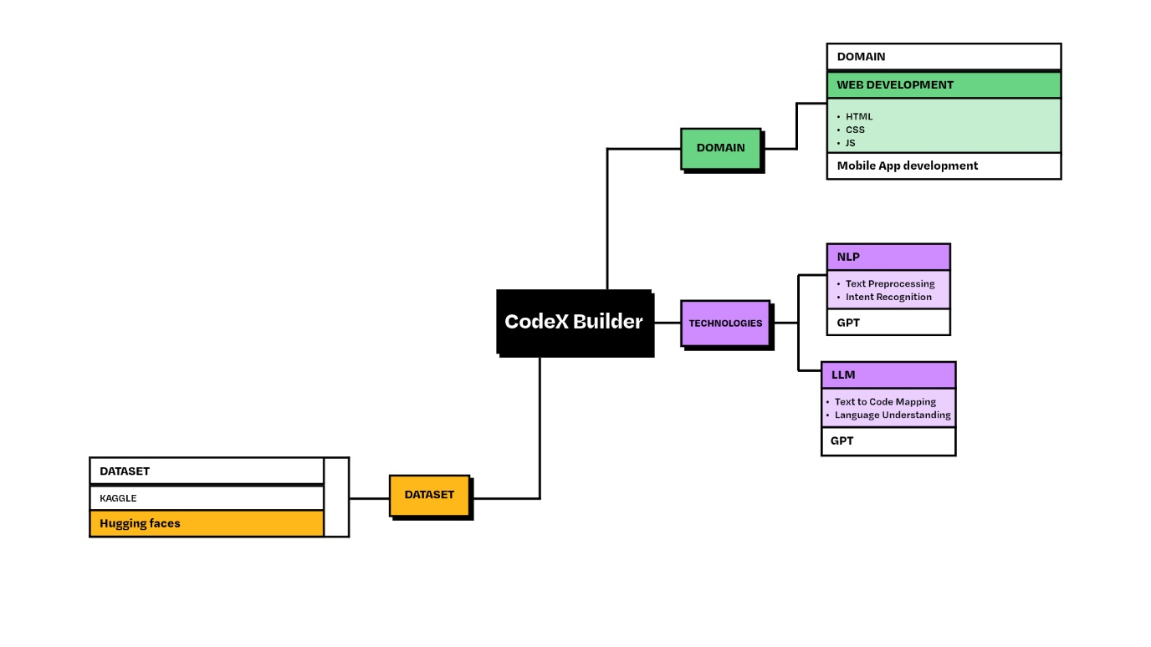
Figure 5 - Context Diagram

4.8 Use Case Diagram
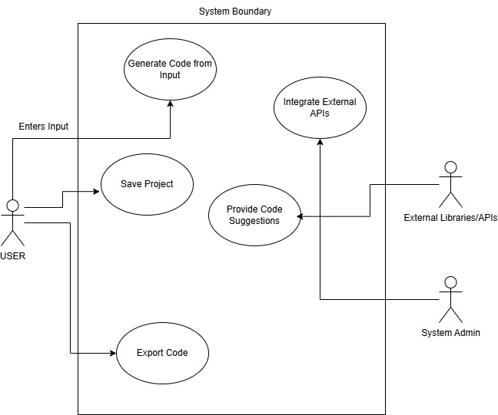
Figure 6 - Use case diagram.

4.9 Use Case Description
- Generate Code from Natural Language Input: The user inputs a command like “Create a button,” and the system generates the corresponding HTML/CSS/JavaScript code.
- Render Code in Real-Time: After generating the code, the system renders it immediately on the screen.
- Provide Code Suggestions: The system offers suggestions for improving or expanding the generated code.
- Save Project: The user can save their progress for future editing.
- Export Code: The system allows the user to export the generated code files (HTML, CSS, JS).

4.10 Requirements

4.10.1 Functional Requirements
- Natural Language Command Input: The system must allow users to input commands in natural language to generate HTML, CSS, and JavaScript code.
- Real-time Code Rendering: The system should display the generated code in real-time on a split-screen interface.
- Customization Options: The user should be able to modify the generated code using additional commands, such as changing the colour, font size, or layout of elements.
- Error Handling: The system must provide feedback when an invalid command is entered and suggest corrections.
- Export Functionality: Users should be able to export the generated code as HTML, CSS, and JavaScript files.

4.10.2 Non-Functional Requirements
- Scalability: The system should handle a growing number of users and commands efficiently.
- Cross-Browser Compatibility: The editor must work seamlessly across modern browsers (Chrome, Firefox, Edge).
- Performance: Code generation and rendering must be completed in under 1 second.
- Security: All user data and commands must be securely processed and stored.

4.11 Chapter Summary
Chapter 4 outlined the core requirements of the CodexBuilder system, detailing how stakeholders’ needs were identified and captured using different elicitation methods. Functional and non-functional requirements were specified, providing a roadmap for building, and testing the system.

CHAPTER 05: TESTING

5.1 Chapter Overview
This chapter outlines the testing ..

5.2 Testing Criteria

5.2.1 Functional requirements validation

5.2.2 Non-functional requirements evaluation

5.2.3 Model Performance Metrics

5.3 Functional Testing

5.3.1 Unit Testing

5.3.2 Integration Testing

5.3.3 System Testing

5.4 Non-Functional Testing

5.4.1 Performance Testing

5.4.2 Scalability Testing

5.4.3 Usability Testing

5.4.4 Reliability Testing

5.5 Model Testing

5.5.1 Metrics

5.5.2 Dataset Testing

5.5.3 Robustness

5.6 Edge Case Testing

5.7 Limitations of Testing Process

5.8 Testing Results and Discussion

5.9 Chapter Summary

Chapter 6: Interim Conclusion
6.1

Reference

Robins, A., Rountree, J., & Rountree, N. (2003). Identifying and addressing the barriers to programming: A survey of students in introductory computer science. ACM Computing Surveys, 35(3), 268–299. https://doi.org/10.1145/776808.776810
Allamanis, M., Barr, E. T., Devanbu, P., & Sutton, C. (2018). A Survey of Machine Learning for Big Code and Naturalness. ACM Computing Surveys (CSUR), 51(4), 81.
Chen, M., Tworek, J., Jun, H., Yuan, Q., Pinto, H., Kaplan, J., Edwards, H., Burda, Y., et al. (2021). Evaluating Large Language Models Trained on Code. arXiv preprint arXiv:2107.03374.
Sales, J.E. (2020). Investigating principles and challenges in natural language programming.
Andreas, J., Klein, D., & Rush, A.M. (2017). Exploring natural language programming systems for executable code
Liu, C., Li, M., & Shao, L. (2020). A survey on NLP in programming and code generation.
Wong, M.-F. (2023). Enhancing programming with AI-powered code suggestions.
Floyd, R. (2020). Web design platforms and non-programmer accessibility: An analysis of Webflow and Wix.
Allamanis, M., Tarlow, D., Gordon, A.D., & Wei, Y. (2018). Code completion using natural language processing.
Gupta, A., Patel, N., & Rajan, S. (2020). Applications of NLP in front-end code generation.
Code.org, CSTA, & ECEP Alliance. (2020). 2020 State of Computer Science Education Report. Retrieved from https://advocacy.code.org/.
National Center for Education Statistics (NCES). (2021). Undergraduate degree fields: Number and percentage of degrees conferred by postsecondary institutions. Retrieved from https://nces.ed.gov/.
Stack Overflow. (2023). Stack Overflow Developer Survey Results 2023. Retrieved from https://insights.stackoverflow.com/survey
Winer, B. (2021). The evolution of web-based code editors and the role of user experience. Journal of Software Development, 14(2), 102-115.
Zhou, J., Liu, Y., & Xie, T. (2022). Advancements and limitations of NLP in code generation: A review of tools like ChatGPT and Copilot. ACM Transactions on Software Engineering and Methodology, 31(3), 1-23.
Khan, R., Patel, S., & Lee, J. (2022). Real-time interactivity in code generation: Challenges with NLP and rendering technologies. Proceedings of the IEEE International Conference on Artificial Intelligence and Virtual Reality, 18(2), 341-352.
Jin, H., Zhu, P., & Wang, X. (2023). Optimizing NLP models for front-end frameworks: A study on compatibility and performance. Frontiers in Computer Science, 29(5), 455-470.
Vaswani, A., Shazeer, N., Parmar, N., et al. (2017). Attention is all you need. Advances in Neural Information Processing Systems, 30, 5998-6008.
Brown, T. B., Mann, B., Ryder, N., et al. (2020). Language models are few-shot learners. arXiv preprint arXiv:2005.14165.
Smith, J., & Jones, R. (2021). Cross-browser compatibility challenges in modern web applications. Journal of Web Development, 18(2), 145-158.
Xu, L., Peng, B., & Li, M. (2022). NLP applications in code generation and the gaps for front-end development. ACM Computing Surveys, 54(6), 121-145.
Johnson, K., & Lee, H. (2022). Designing intuitive AI-powered interfaces for novice users. IEEE Transactions on Human-Machine Systems, 52(3), 433-441.

